Template Vaccine Statement

Use the sample vaccine policy statement below as is, or modify it to reflect your practice’s own strong statement of support for the vital role vaccination plays in safeguarding the health of children. By taking the first step to learn about the I Vaccinate Provider Toolkit, you have clearly expressed a commitment to helping parents who are hesitant to have their child vaccinated because of scientifically invalid information they have encountered on the Internet or through the news media. The following template Vaccine Policy Statement can be printed, signed and displayed in your office, and we encourage the use of the accompanying letter on your website, in an email or printed letter to families, or within your practice Welcome Packet for new patients and families.

This policy statement has been adapted from the Immunization Action Coalition in Minnesota, originally developed by clinicians at All Star Pediatrics in Lionville, Pennsylvania. All Star Pediatrics posts their policy in every exam room and gives it to parents at prenatal “meet and greet” and newborn clinic visits. As a result, parents new to All Star Pediatrics know exactly where their doctors stand on immunization, and the families of established patients feel supported in the choice they’ve made to immunize their children. All Star Pediatrics’ policy statement was originally published as a letter to the editor in AAP News, May 2008, by Bradley J. Dyer, MD, FAAP, and his colleagues at All Star Pediatrics.

[Your Practice Name] Vaccine Policy Statement
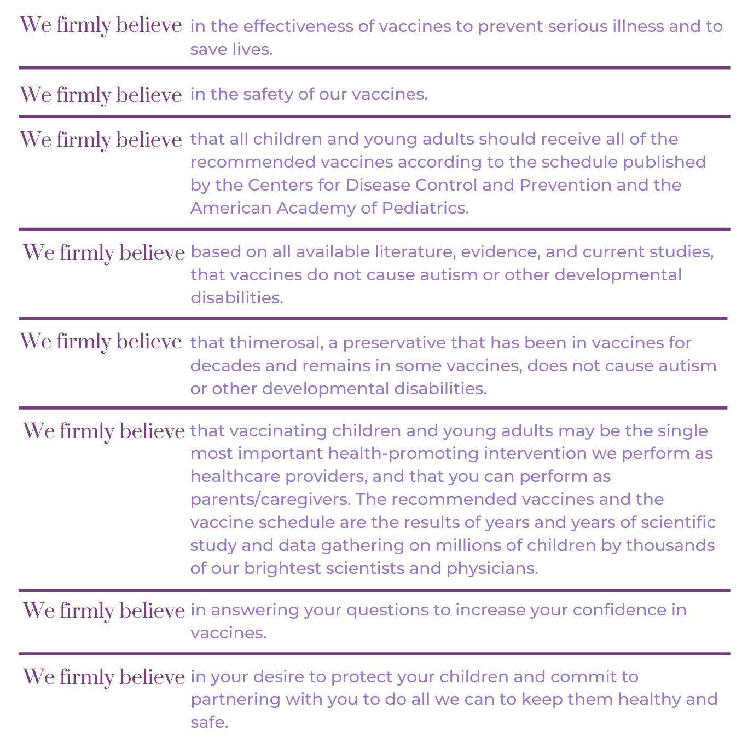

Dear Parent,
Here at [Your practice name], we believe in vaccines. As a medical team who researches the most current medical advances from credible, reputable sources, we believe that vaccines effectively prevent serious illness and save lives. Vaccination is the single most important health intervention we perform as your healthcare provider. We also recognize that as parents, your desire to protect your children is your utmost priority. Please know, it is ours as well, and we commit to partnering with you to answer your questions and do everything in our power to keep your family healthy and safe.
Vaccines are truly a victim of their own success. It is precisely because vaccines are so effective at preventing illness that we are even discussing whether or not they should be given. Because of vaccines, many of you may have never seen a child with polio, tetanus, whooping cough, bacterial meningitis, or even chickenpox, or known a friend or family member whose child died of one of these diseases. Such success can make us complacent about vaccinating.
But such an attitude, if it becomes widespread, can only lead to tragic results. After publication of an unfounded accusation (later retracted) that MMR vaccine caused autism in 1998, many parents chose not to vaccinate their children. As a result of underimmunization, the world has since experienced large outbreaks of measles, with several deaths from disease complications. In 2012, there were more than 48,000 cases of pertussis (whooping cough) in the United States, resulting in 22 deaths. Most victims were infants younger than six months of age. Many children who contracted the illness had parents who made a conscious decision not to vaccinate. In 2015, there was a measles outbreak in Disneyland, California (probably started by an infected park visitor who had traveled from the Philippines). The outbreak eventually spread to 147 people and, again, many were too young to have been vaccinated.
When you don’t vaccinate, you take a significant risk with your child’s health and the health of others around them. By not vaccinating, you also take advantage of the thousands of others who do vaccinate their children, thereby decreasing the likelihood that your child will contract a vaccine preventable disease. Our practice is fully committed to addressing the vaccine hesitancy you have so that we may help you to understand the vital importance of vaccinating your child.
We are making you aware of these facts not to scare or coerce you, but to emphasize the importance of vaccinating your child. We recognize that the choice may be a very emotional one for some parents. We will do everything we can to help you understand that vaccinating according to the schedule is the right thing to do. However, should you have doubts, please discuss these with your healthcare provider at [Your Practice Name]. Our full team is up-to-date on the most credible scientific literature available on vaccinations, as well as the most recent recommendations from the U.S. Centers for Disease Control and Prevention.

— Continued on next page —
We recognize that some parents may request a delayed or alternate schedule to accommodate parental concerns or reservations. Please be advised that delaying or “breaking up the vaccines” to give one or two at a time over two or more visits goes against expert recommendations, can put your child at risk for serious illness (or even death) and goes against our medical advice as providers at [Your Practice Name]. Such additional visits require additional co-pays on your part.
Because we are committed to protecting the health of your children through vaccination, we recommend that all of our patients be vaccinated. Infants will receive all recommended vaccines by three months of age, with additional recommended vaccines as well as booster doses by two years of age. Children will receive additional recommended booster doses by the time they are seven, and will be given recommended 11–12-year preteen vaccinations by the time they are 13 years old. We will complete 16-year teen vaccinations before each child’s 17th birthday. And, we will also give your child/teen an annual influenza vaccination unless they receive it at a school clinic or pharmacy.
Finally, if you should absolutely refuse to vaccinate your child despite all our efforts, please understand that we will not stop recommending vaccinations at every child visit. Please recognize that by not vaccinating, you are putting your child at unnecessary risk for life-threatening illness and disability, and even death. As medical professionals, we feel very strongly that vaccinating your child on schedule with currently available vaccines is absolutely the right thing to do to protect all children and young adults.
Thank you for taking the time to read this policy. Please feel free to discuss any questions or concerns you may have about vaccines with any one of us.
All the healthcare providers of [Your Practice Name]
List names and signatures of healthcare providers, if desired.

